***AWS Lambda Function to Start and Stop an EC2 Instance***

***Summary:***

This project aims at creating an AWS Lambda Function to Stop and Start an EC2 Instance.

The project involves Creation of a Lambda Function, modifying an IAM Role and executing it.

***Objectives:***

1. Create a Lambda Function.
2. Modify IAM Role.
3. Execute the IAM Role.

***Background:***

***AWS Lambda Service:*** Lambda falls under “Compute” service in AWS (Amazon Web Services). Using Lambda, we can code without provisioning or managing servers. Lambda automatically runs our code without requiring us to provision or manage servers. We just need to write the code and upload it to the Lambda Function. Lambda executes the code only when needed. It grows automatically supporting from a few requests to thousands of requests. We are charged for every 100ms our code executes and the number of times it is triggered. We are charged only for the compute time our code consumes and not charged when the code is not being executed.

***Amazon EC2***: It is a Secure and resizable compute capacity for virtually any workload. Amazon Elastic Compute Cloud (Amazon EC2) offers the broadest and deepest compute platform, with over 500 instances and choice of the latest processor, storage, networking, operating system, and purchase model to help you best match the needs of your workload. We are the first major cloud provider that supports Intel, AMD, and Arm processors, the only cloud with on-demand EC2 Mac instances, and the only cloud with 400 Gbps Ethernet networking. We offer the best price performance for machine learning training, as well as the lowest cost per inference instances in the cloud. More SAP, high performance computing (HPC), ML, and Windows workloads run on AWS than any other cloud.

***Lab Files:***

Instance Name: functionwizard

Region: [US East (N. Virginia) us-east-1](https://console.aws.amazon.com/ec2/v2/home?region=us-east-1#LaunchInstances:)

Instance ID: i-004c7c2ce914e6459

Lambda Function Name: FunctionWizard

Drive Link to Python codes (written in TXT files): <https://amityedu96491-my.sharepoint.com/:f:/g/personal/viransh_bhardwaj_s_amity_edu/ErydEX8_ZLJGm67P9NC_0TwBT6icmywm2w_1b6ibXoSvzg?e=yf6UeP>

***Launching an instance:***

1. In the search bar of the AWS Management Console, search for EC2 and chose the first option.

1. Click on Launch Instance:



1. Type The name of the instance and chose appropriate AMI. Here I have chosen amazon Linux.

1. Choose the instance type:Graphical user interface, application

   Description automatically generated
2. Create a keypair (if required).

1. Under network settings, either create a security group or chose an existing security group and check all the boxes as shown.

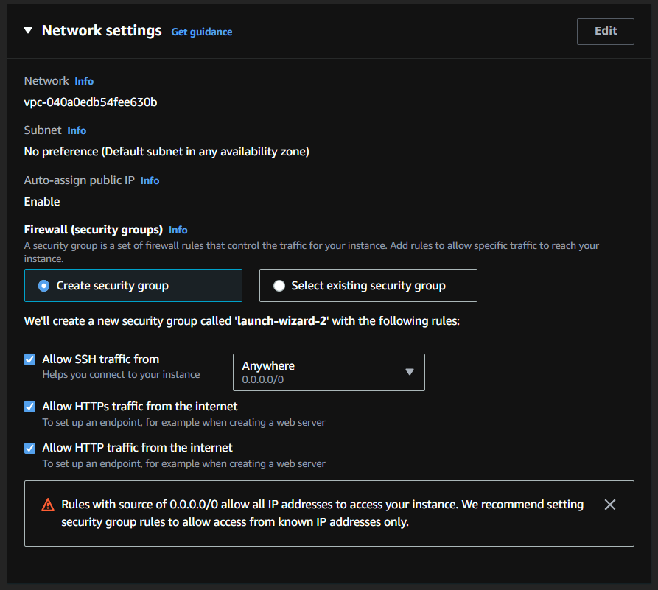

1. Launch The instance.

1. View all instances and review the IPv4 address of the instance.

1. Your instance has been launched successfully.

***Lambda Function for Stopping an Instance.***

1. Select the desired region. I have selected N Virginia region.

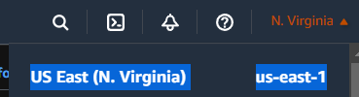

1. Search Lambda and choose the first option from the list of services.

1. Under functions, click on “Create Function”.

1. Click on “Author from Scratch” to write our own Lambda Function.

1. Provide a name to the Function.
2. Select “Python 3.9” from the drop-down list of Runtime.

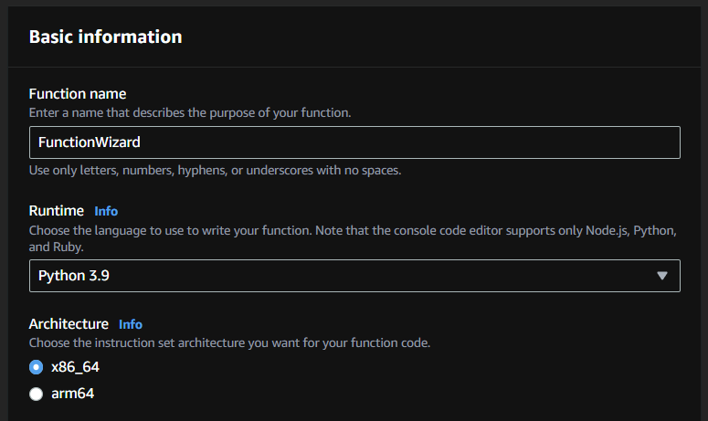

1. Select “Create a new role with basic Lambda Permissions”. This will create a new Role with the same name as that of Function name with some random key as a suffix.

1. Create the Function and open Code Tab in the pane that occurs below.

1. Add the following code in the function. Keep in mind, the region and instance id to be added in the function code.

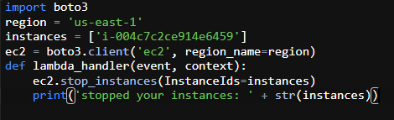

1. Click on “Test” button and select “Configure test event”.

1. Add a name to the event “testStopEC2”. You don't need to change the JSON code for the test event—the function doesn't use it.

1. Click on test.

***Modify IAM Role:***

1. Open IAM Console from search bar and select “Roles” from left panel and click on the Role which starts with the same name as that of the Lambda Function.

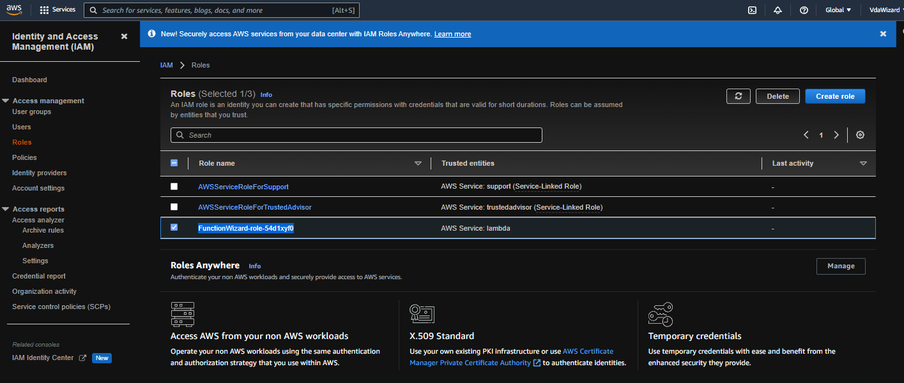

1. Click on “Attach policies” from add permissions option.

1. Search for “ec2” in the search box and select “AmazonEC2FullAccess” from the list and click on “Attach Policy” button.

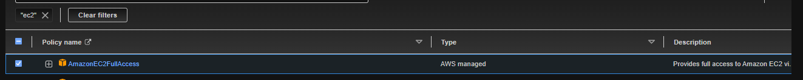

1. Go back to your Lambda function and click on deploy for the changes to take effect. Test the function.

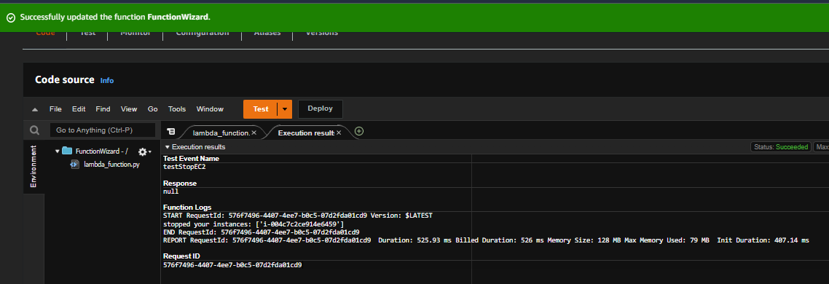

1. Open the EC2 Dashboard and open Instances (Running). You will find the instance has been stopped.



Here we created a function named as *lambda_function.py* which stops the instance in *us-east-1* region. Now we shall create a new function or change the existing code with the given *python* code.

***Lambda Function for Stopping an Instance.***

1. Under the same function, in the left pane of Code Tab, right click and add file “start_function.py” and add the following code in it with the region in which the instance is running and correct instance id.

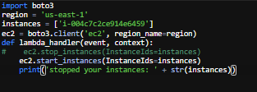

1. DEPLOY and test the function.

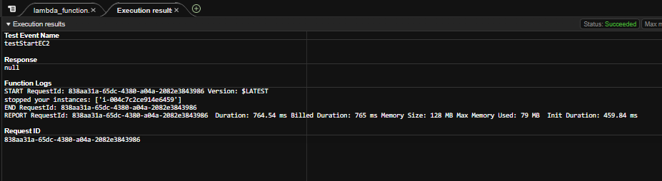

1. Go back to EC2 Dashboard and verify the instance status. The instance should be running/initializing.



1. The instance has successfully started again.

Clearly the objective of creating a function that stops and starts an instance has been accomplished. Furthermore, as per the requirements of the user, a CloudWatch Alarm can also be created to start and stop the instance.

“Note That the IPv4 and IPv6 address of the instance has been changed.

This is because of the fact that IPs are a fixed resource.

There are not many IP addresses.

Thus, On Stopping an Instance, The Instance IP is freed and on restarting the Instance, A new IP is assigned to it”

***Brief:***

Launched an EC2 instance.

Created a Lambda Function to perform required tasks.

Created python codes to execute start and stop tasks.

Modified the IAM Roles for proper access to the Function.